GEOINT / OSINT INTEGRATED ANALYSIS
Integrated Assessment of Industrial Facilities
Radio Plant and JSC NPP Rubin
Penza, Russian Federation

Project Title | Integrated Assessment of Industrial Facility: Ownership, Operational Profile, and Defense Relevance
Location | Radio Plant – 53.2269, 45.0063 · NPP Rubin – Baudukova St., 2, Penza
Assessment Type | GEOINT / OSINT Integrated Analysis
Sources | Commercial satellite imagery (Google Earth), corporate registries, government procurement data, sanctions databases, open media reporting.

This assessment draws on the source material identified above. No external research, verification, or supplementation of the source case has been performed in preparing this report; all findings, confidence levels, and limitations are those stated in the source.

Executive Summary
Two adjacent industrial facilities located on Baudukova Street in Penza were assessed using integrated GEOINT and OSINT methods: the Penza Radio Plant and JSC NPP Rubin.
The analysis indicates that the Radio Plant functions as a large-scale electronics manufacturing facility operating under state control within the Rostec structure and supplying military command, control, and communication systems.
The adjacent NPP Rubin site demonstrates characteristics consistent with integration, storage, and staging of mobile military systems.

Key Indicators
- State ownership within Rostec
- Declared defense-oriented production
- Confirmed government and defense procurement
- Inclusion in multiple international sanctions regimes
- Persistent presence of military vehicles at the Rubin site
- Large workforce and active logistics operations
- Open-source reporting of a UAV strike targeting the Radio Plant in July 2025
Table 1. Per-facility assessment with stated confidence
Assessed facility | Assessment
Radio Plant | High confidence – military-oriented production facility
NPP Rubin | High confidence – military integration and support facility

1. Area Overview
The assessed facilities are located within an established industrial zone in northern Penza.
The Radio Plant and NPP Rubin occupy separate secured compounds positioned directly opposite each other along Baudukova Street, with an approximate separation distance of ~20 meters between perimeter boundaries.
Both sites are enclosed by perimeter fencing (~5 m height) with controlled access points and surveillance systems.
Their physical proximity, shared logistics characteristics, and complementary functional profiles suggest operational linkage.
Radio Plant and NPP Rubin compounds, Penza — annotated overhead imagery
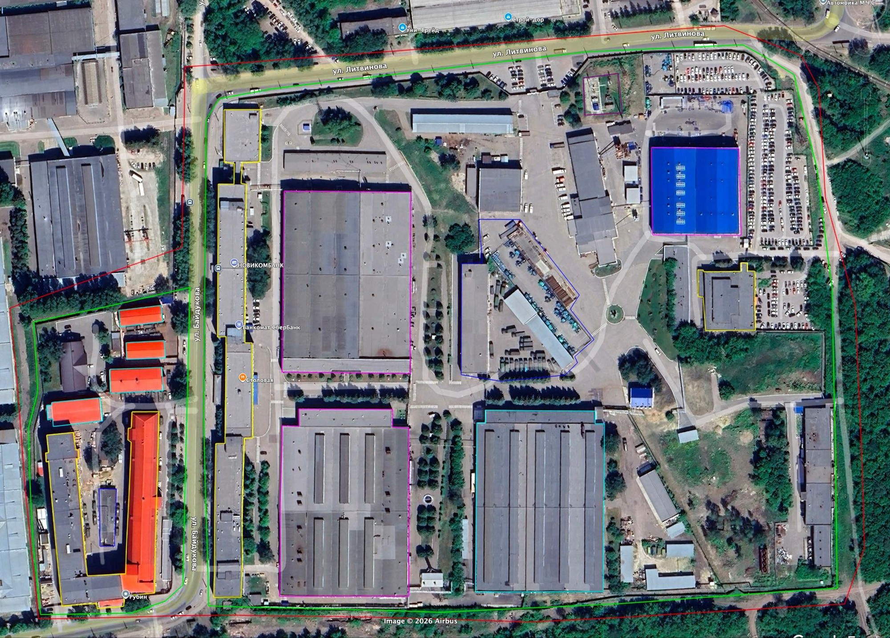
Both assessed compounds positioned directly opposite each other along Baudukova Street, consistent with the ~20 m perimeter separation stated in the source.

External Infrastructure
Table 2. External infrastructure relative to the assessed compounds
Feature | Stated distance / note
Rail logistics hub | ~2 km north
Large electrical substation | ~1 km distance (visual confirmation limited)
City CHP plant | ~3–4 km distance

Direct road access connects the facilities to the regional transport network and the rail hub.

2. Radio Plant — Physical Infrastructure
Total site area: approximately 170,000 m².

Penza Radio Plant — overhead imagery, 53.2269, 45.0063
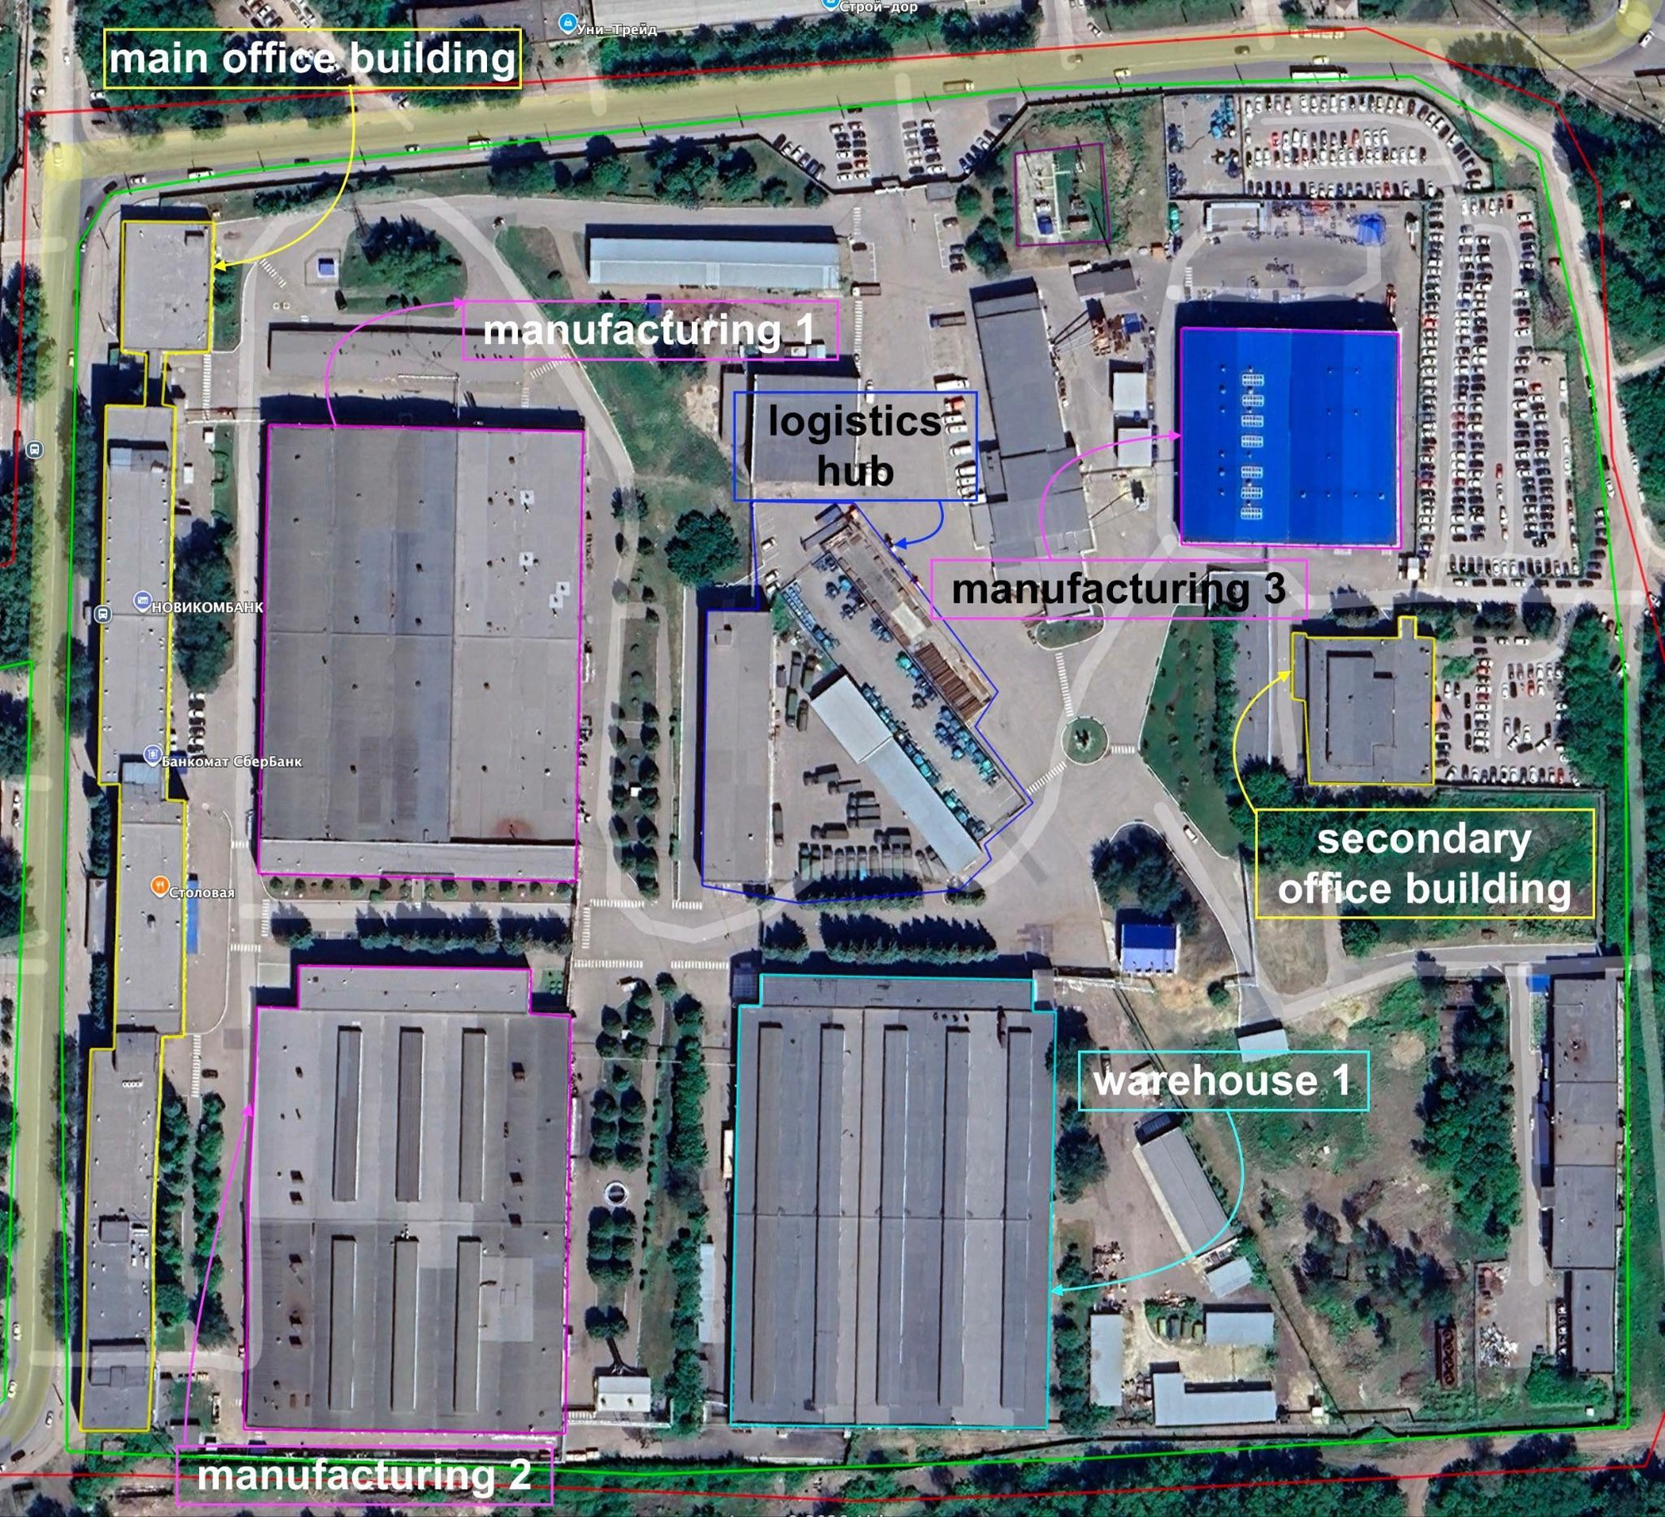
Site footprint of approximately 170,000 m². Labelled structures in the source imagery: main office building, manufacturing 1–3, logistics hub, secondary office building, warehouse 1.
Table 3. Radio Plant structural inventory (consolidated from sections 2.1–2.5)
Structure | Area (m²) | Floors | Height | Observed characteristics
Main office | ~6,700 | 3 | ~15 m | —
Secondary office | ~1,700 | 2 (estimated) | — | Low confidence
Manufacturing Building 1 | ~12,000 | — | — | Connected to Building 2 via overhead pipeline; no visible heavy-industry indicators
Manufacturing Building 2 | ~12,000 | — | — | Complex roof geometry; multiple ventilation units; roof contamination patterns consistent with active use
Manufacturing Building 3 | ~4,000 | — | ~15 m | Extensive glazing; approximately 20 rooftop ventilation units (~1 m diameter)
Primary warehouse | ~12,000 | — | — | —
Logistics area | ~8,000 | — | — | —
On-site electrical substation | ~750 | — | — | —

2.1 Administrative Buildings

Observed
- Main office: ~6,700 m², three floors, ~15 m height
- Secondary office: ~1,700 m², estimated two floors (low confidence)
Assessment
The administrative scale is consistent with a large industrial workforce.

2.2 Manufacturing Facilities

Manufacturing Building 1
- Area: ~12,000 m²
- Connected to Building 2 via overhead pipeline
- No visible heavy-industry indicators

Manufacturing Building 2
- Area: ~12,000 m²
- Complex roof geometry
- Multiple ventilation units
- Roof contamination patterns consistent with active use
Open-source information indicates assembly-related operations.

Manufacturing Building 3
- Area: ~4,000 m²
- Height: ~15 m
- Extensive glazing
- Approximately 20 rooftop ventilation units (~1 m diameter)
Assessment
The structural characteristics and ventilation density are consistent with controlled-environment electronics or precision assembly operations.
Radio Plant building footprint by structure, as stated in the source.
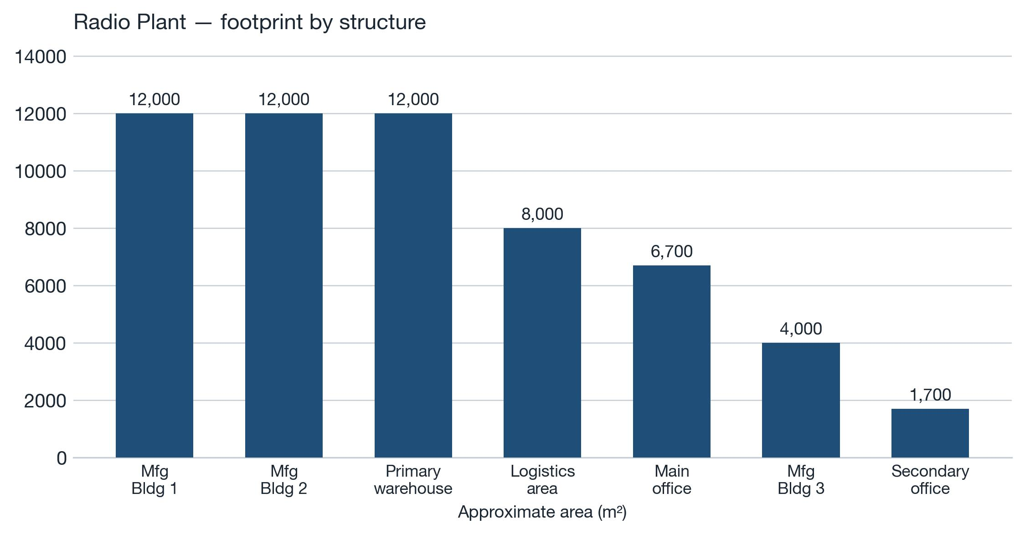
All values are the source's approximate areas; no value has been estimated or derived.

2.3 Workforce Indicators

Observed
- Approximately 370 passenger vehicles
- Full parking occupancy
- No employee buses or organized transport observed
Assessment
The observed parking capacity suggests a workforce likely exceeding 1,000 personnel (analytical estimate).
Two controlled entry points are located on the north and east sides.

2.4 Storage and Logistics
- Primary warehouse: ~12,000 m²
- Logistics area: ~8,000 m²
- Approximately 27 heavy cargo vehicles observed
Vehicles change position across imagery dates, indicating active logistics turnover.
Assessment
Vehicle type and configuration are consistent with industrial or military logistics (medium confidence).
Observed vehicle and equipment counts at both compounds.
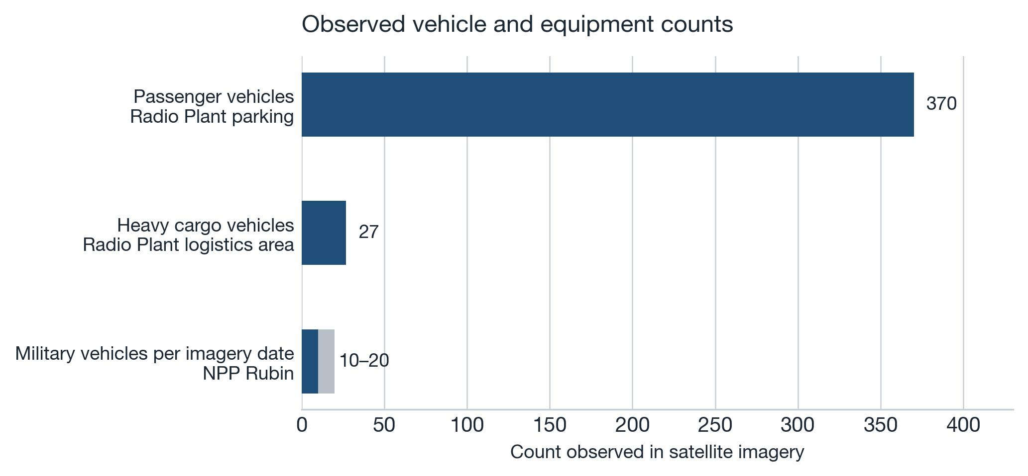
The Rubin military-vehicle figure is shown as the source's stated 10–20 range; the Radio Plant figures are single observed counts.

2.5 Power Infrastructure
- On-site electrical substation (~750 m²)
- External grid infrastructure within 1 km
- City CHP plant located within 3–4 km
Assessment
Power infrastructure supports continuous medium-to-high intensity industrial operations.

2.6 Security

Observed or confirmed via open imagery
- Perimeter fencing (~5 m)
- Dual-layer barbed wire
- Two controlled access points
- Checkpoint structures
- Extensive external CCTV coverage
Assessment
Security level is consistent with controlled-access industrial or defense-related facilities.

3. NPP Rubin — Physical Infrastructure
Total site area: approximately 23,000 m².

3.1 Administrative Building
- Area: ~5,500 m²
- Five floors
- Height: ~18 m

3.2 Storage and Technical Structures
Five warehouse-type buildings (330–620 m² each) with large vehicle-access doors.
One structure includes:
- Additional upper floors (likely administrative or technical use)
- Rooftop ventilation units

3.3 Military Equipment Presence

Observed
- Approximately 10–20 military vehicles per imagery date
- Presence documented across multiple years (since at least 2017)

Equipment types (medium confidence):
- Military logistics trucks (KamAZ-type)
- Armored wheeled vehicles
- Tracked platforms
- Possible specialized command or electronic systems
Vehicles are positioned near warehouse and garage structures and arranged in organized patterns.
Assessment
Persistent presence and infrastructure compatibility indicate long-term operational use rather than temporary storage.

3.4 Access and Security
- Main controlled entry near administrative building
- Additional vehicle gates at warehouse structures
- Perimeter fencing (~5 m) with barbed wire
- External imagery indicates strict access control and surveillance
JSC NPP Rubin, Baudukova St., 2, Penza — overhead imagery
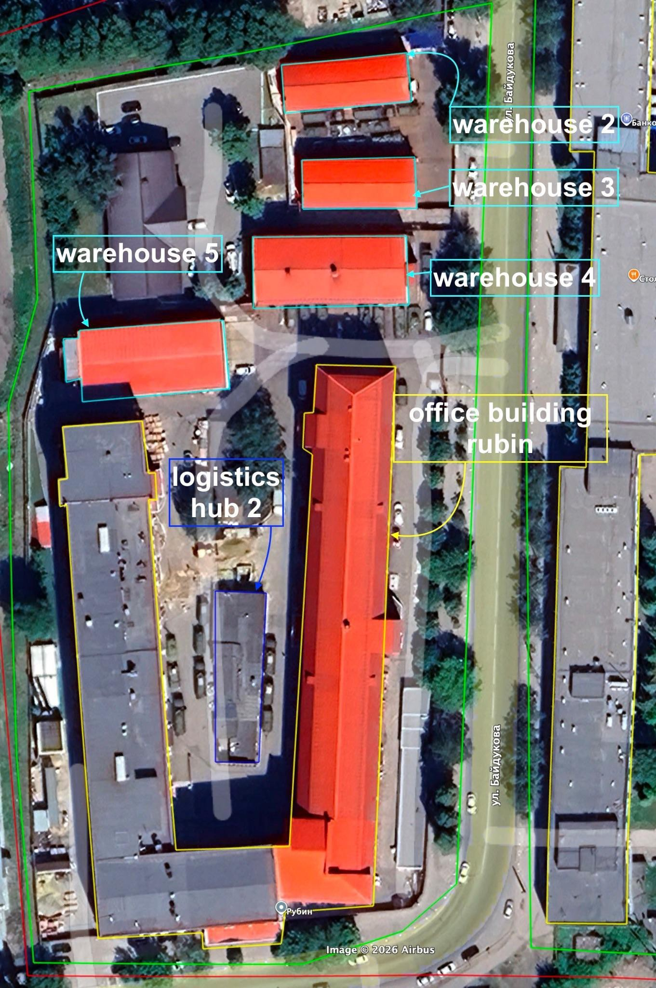
Site footprint of approximately 23,000 m², opposite the Radio Plant across Baudukova Street. Labelled structures in the source imagery: office building Rubin, logistics hub 2, warehouses 2–5.
Table 4. NPP Rubin structural inventory (consolidated from sections 3.1–3.2)
Structure | Area (m²) | Floors | Height | Observed characteristics
Administrative building | ~5,500 | 5 | ~18 m | —
Warehouse-type buildings ×5 | 330–620 each | — | — | Large vehicle-access doors; one structure includes additional upper floors (likely administrative or technical use) and rooftop ventilation units

4. Logistics and External Connectivity

Observed
- Direct road connectivity between the two facilities
- Similar dark-green military-type trucks present at both sites
- Rail logistics hub located ~2 km north
- Direct road access from both facilities to the rail terminal
Assessment
Infrastructure configuration is consistent with staging and shipment of heavy or specialized equipment.

5. Ownership and Control (OSINT)

Radio Plant
- State-controlled entity within Rostec (Ruselectronics)
- Activity classification includes weapons and military equipment production
- Government contracts with defense-related organizations
- Sanctioned by multiple jurisdictions (US, EU, Canada, Japan, Switzerland, New Zealand, Ukraine)

Declared production includes:
- Fire control systems
- Military communication equipment
- Command and control electronics
- Navigation and stabilization systems

NPP Rubin
- Joint-stock company within Rostec structure (Concern Vega)
- Specializes in mobile command systems, secure communications, and automated control systems
- Confirmed Ministry of Defense contracts
- Included in multiple sanctions lists
Ownership, control and functional relationship of the two assessed entities.
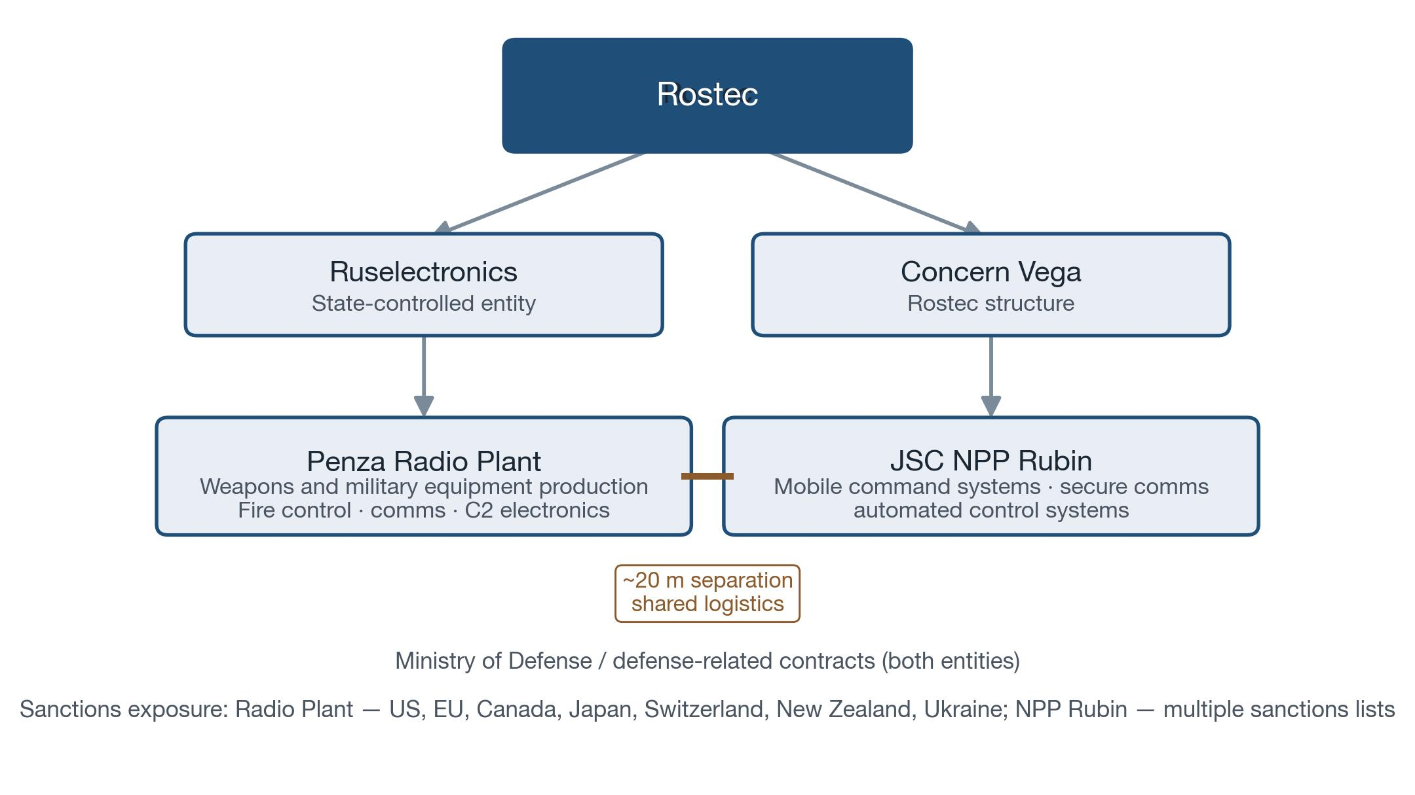
Relationships shown are those stated in section 5 and section 7 of the source; the physical link is the ~20 m perimeter separation stated in section 1.
Table 5. Ownership, contracting and sanctions comparison
Dimension | Radio Plant | NPP Rubin
Ownership / control | State-controlled entity within Rostec (Ruselectronics) | Joint-stock company within Rostec structure (Concern Vega)
Activity classification | Activity classification includes weapons and military equipment production | Specializes in mobile command systems, secure communications, and automated control systems
Government contracts | Government contracts with defense-related organizations | Confirmed Ministry of Defense contracts
Sanctions status | Sanctioned by multiple jurisdictions (US, EU, Canada, Japan, Switzerland, New Zealand, Ukraine) | Included in multiple sanctions lists
Site area | Approximately 170,000 m² | Approximately 23,000 m²

6. Activity and Targeting Indicators

Operational indicators
- Large workforce presence
- Active heavy-vehicle logistics
- Persistent military equipment at Rubin

Targeting indicator:
Open-source reporting indicates that the Radio Plant was struck by UAVs on 31 July 2025, with multiple impact events reported.
Assessment
While based on open-source reporting and not confirmed by post-strike imagery, the targeting is consistent with facilities assessed as military-industrial assets.
Chronology of dated events stated in the source.
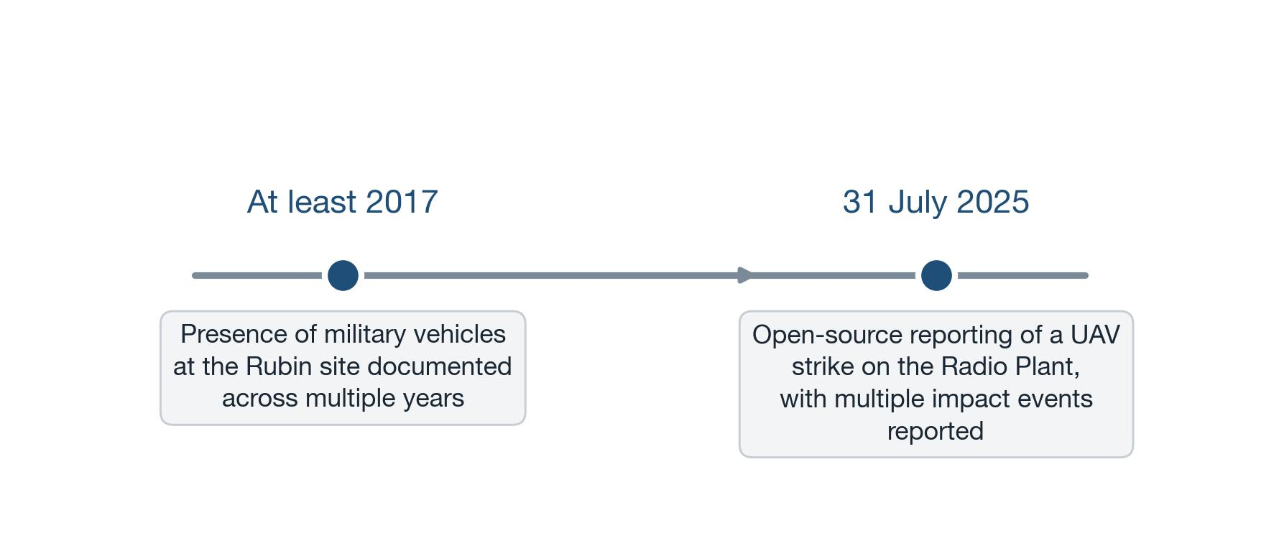
Only dates explicitly given in the source are plotted; the source provides no other date anchors.

7. Functional Integration Assessment

Observed
- Physical proximity (~20 m separation)
- Shared logistics characteristics
- Similar military-type transport vehicles
- Complementary production and integration profiles

Assessment
Most likely functions as a primary manufacturing site for electronic subsystems.
Most likely functions as a facility for:
- Integration of mobile military systems
- Storage and staging
- Preparation for shipment via rail

8. Risk Assessment
Table 6. Risk assessment by category
Category | Assessment
Defense involvement | High
Civilian production indicators | Limited
Military specialization | High
Sanctions exposure | High
Supply chain / compliance risk | Critical

Risk profile by category.
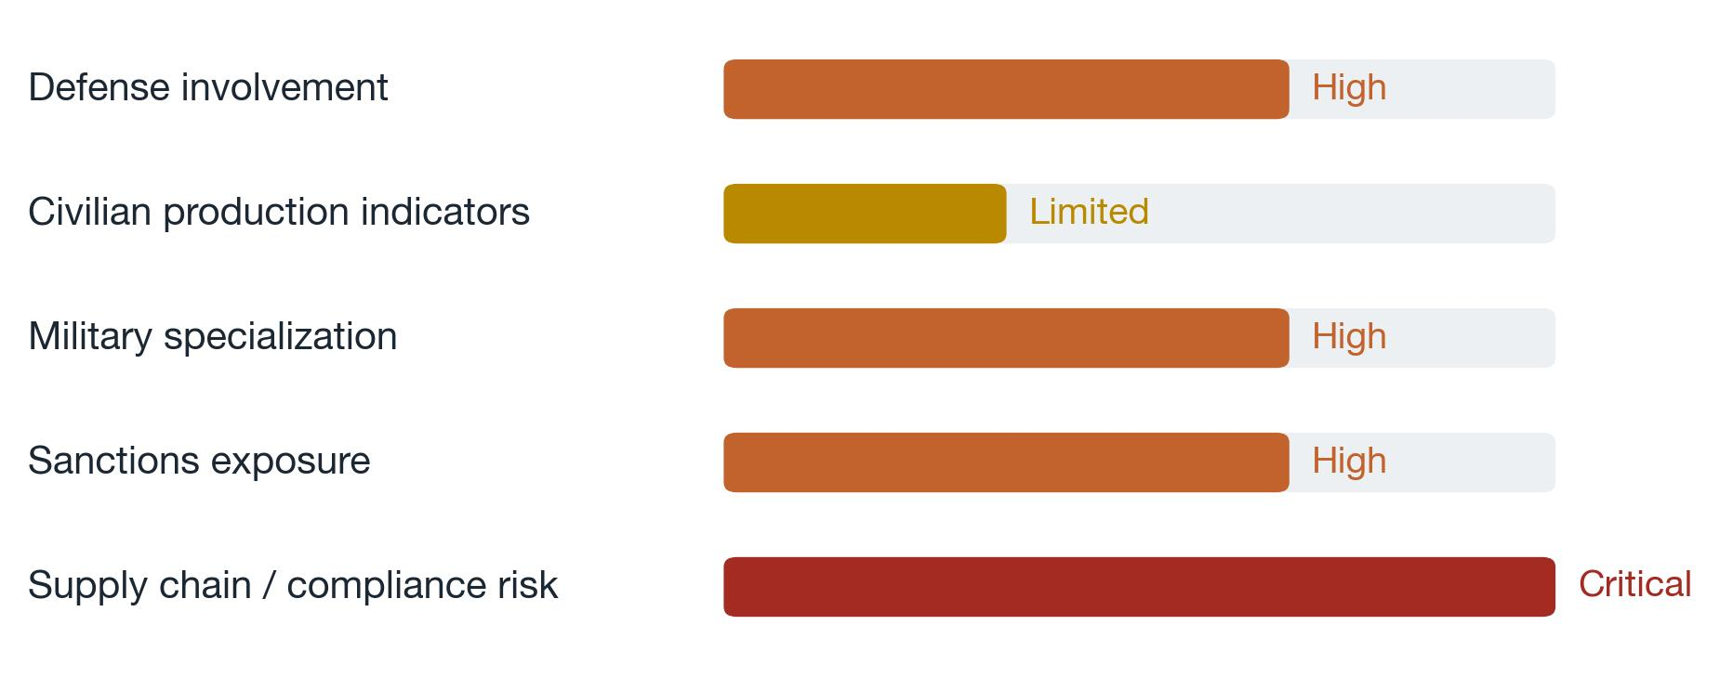
Bar length is proportional to the ordinal rating stated in the source (Limited / High / Critical); it carries no additional quantitative meaning.
Overall Operational Risk Level
Overall Operational Risk Level: High – Military-Oriented Industrial Facilities

9. Confidence Assessment
Overall Confidence: High

Supporting factors
- Strong GEOINT–OSINT consistency
- State ownership within Rostec
- Confirmed defense procurement and product profiles
- Persistent military equipment presence
- Large workforce and active logistics
- Inclusion in multiple sanctions regimes

Limitations
- Medium confidence in detailed equipment identification from satellite imagery
- Limited post-strike satellite coverage
- Some infrastructure interpretations based on indirect indicators
Table 7. Stated confidence qualifiers and limitations
Evidence strand | Direction | Stated limitation / qualifier
Detailed equipment identification | Medium confidence | Medium confidence in detailed equipment identification from satellite imagery
Post-strike assessment | Unconfirmed | Limited post-strike satellite coverage
Infrastructure interpretation | Indirect indicators | Some infrastructure interpretations based on indirect indicators

